1st Park Street Scout Group

Policies and Processes
Author: Group Scout Leader, Mr Christopher Holliss – V4 - 2018
Group Scout Leader, Mr Christopher Holliss – V3 - 2017
Group Scout Leader, Mr Christopher Holliss - V2 - 2016
Group Scout Leader, Mrs Niki Dunn – V1 - 2012

Committee for approval and review: Group Executive Committee
Circulated to: Section Leaders, Assistant Leaders, Executive Committee
Annual Review: 1st September

1st Park Street Scout Group, Rear of 29 – 31 Birchwood Way, Park Street, St Albans, Hertfordshire, AL2 2SF
Registered Charity No. 271282

Document purpose:
The purpose of this document is to clarify and formally adopt policies within the group. It is intended that this document is reviewed annually by the group executive committee with appropriate comments from section leaders, assistant leaders and helpers.

Policy and Process Index
- Group Financial Processes
  - Group subscription
  - Process associated with collection and payee details
  - Process and amount for section termly float
  - Process for application to the group hardship fund (for payment of scouting subs/camps/uniform)
  - Annual census and capitation payment
  - Gift aid
  - Event and camp finances

- Scout Shop
  - Payment of uniform from group account money

- Group Camping Equipment
  - Process for booking dates
  - Process for requesting equipment
  - Process for reporting faulty, lost or broken equipment
  - Process for refilling of gas bottles on return from residential events

- Membership information
  - Personal details upon OSM / MyScout
  - Group membership data and financial systems

- Leadership Information
  - Full Group Uniform
  - Leaders, Assistant Leaders & Section Assistant Uniform
  - Group directory
  - Group leaders meetings
  - Executive meetings
  - Training advisors and role of local training manager
  - HQ opening and closing checklist
  - None hut based meetings
  - Risk Assessments
  - Leader Uniform
  - Parents rota
  - Communications to and from parents

- Health and Safety/Welfare Policies
  - Health and safety
  - Child Protection / CRB requirements
  - First aid
  - Fire

- Group Behaviour policy
  - Group policy for behaviour

- National Policies and Factsheets
  - Scout Association (UK) Policy, Organisation and Rules (POR)
  - Scout Association (UK) Factsheets

- Group Waiting Lists and Moving up
  - Waiting list process
  - Moving up process
  - Parental leaders

  - Group Financial Processes

  - Group Subscription Amount
Termly subscription payment is £42 or half termly £21 per child. New members to the group will pay a £10 (one off) registration fee on top of their first subscription payment to cover the cost of scarf and badges.
Subscription amount will be reviewed annually in July each year and changes/amendments will be effective from the autumn term in September.

  - Process associated with collection and payee details
Subscriptions shall be collected by sections from parents leading up to or within the first 2 weeks of the autumn/spring/summer terms using the groups MyScout and GoCardless payment system. Over seen by the group treasurer and GSL, sections are responsible for the creation of payment schedules and their up keep within their sections OSM. Payment dates for these schedules shall be set as 1st September (autumn) 1st January (spring) 1st April (summer) terms. Following this the groups preferred method of payment is BACS (1st Park Street Scout Group, Barclay, Sort Code 207409 Account No. 90667757), however other payment methods are accepted although this should be discouraged by the leaders. Cheques should be made payable to ‘1st Park Street Scout Group’ with the child’s name and section written on the back. If payments are made by cash, this needs to be in an envelope with the child’s name, section name and amount clearly marked upon the front, this must then be given to the group treasurer ASAP. The Leader is to also give the parent a receipt from their sections receipt book

None payment of subscription within the allocated 2 weeks shall result in one further reminder. If payment is not received by the group following this the child will not be allowed to attend any further meetings or events held by the group until the outstanding payment has been made and received. All none subscriptions payment should also be communicated to the Group Treasurer and GSL.

  - Process and amount for sections float
The group is to provide each section with a £50 float per term. Sections will be expected to keep a full record of all outgoing payments and provide the treasurer with hard copy receipts which should be handed to the treasurer within an envelope with the sections name upon the front before the float will be replaced for the following term. Any leader out of pocket expenses for items that are to be taken from the float amount will be required to email both the group treasurer and GSL with a copy of a receipt/s along with their banking details and they shall be reimbursed ASAP via BACS.
Although the float is set at £50 a request for more if required can be sent to the GSL for approval.

  - Process for application to the group hardship fund (for payment of scouting subs/camps/uniform)
Applications for assistance with subs, camp fees and purchasing of uniform from the group hardship fund should be made to the GSL, group chairman and the group treasurer who will make a decision based on the facts presented to them.

  - Annual census and capitation payments
The Scout association requires all groups within the country to fill out a census form of our numbers and our diversity.
Capitation is payable for all invested young people under the age of 18 to which the present cost is £43.
The capitation fee is broken down as: Scout association £25, Hertfordshire scouting £12, St Albans District £2.50 an adult development levy £1. A discount of £1 off per person is also applied by the District for prompt payment.
Sections must make sure that all information requested by the group within their OSM personal details area is present and correct by the start of January for this purpose.

  - Gift Aid
So that the group may claim gift aid upon subscriptions, it requires a parent who is a UK taxpayer to except the allow gift aid within the personal details section upon OSM. Annually, the group treasurer will complete an audit of gift aid via OSM and highlight to section leaders any that are missing; in turn the leaders will request that parents complete this item with the choice to give or not.

  - Event & Camp Finances
The group has moved to collecting its event and camp monies for example (summer camp, Archery, Kayaking) using the group’s MyScout and GoCardless payment system. MyScout & GoCardless charge 2.95% on the total amount of all transactions so sections must when collecting monies by this means add this fee or more upon the original fee (example Archery £5 per person would be £6).
It is at the discretion of a section that they can choose to collect an event by the means of cheque or cash. The section is fully responsible for all incoming and outgoing monies to which must be accounted for and presented to the group treasurer & GSL on completion of the event. For camp budget example view Appendix 3.
Monies, receipts, invoices and all concerning paperwork stating who went and paid for the event should be in a sealed envelope, clearly marked with the section name, event, and amount then delivered to the Group Treasurer.
ALL events run by or participated by any of the group’s sections such as District Gala’s where the section or group is to be charged for taking part is to pass that charge equally onto the members taking part. Where there is a cost for the leader to

CONTIUNED….
attend the event this cost should also be spread equally across those attending unless this would make the event fee untenable.
A rule of thumb when costing events and activities is if a section has 24 then you should price that only 14 will take part and that you are to break even as a minimum requirement with that amount. All profit created from any addition members above the minimum number taking part in an event such as shooting or a camp is profit for the group to be used as a whole and is NOT for the soul use of that particular section.

- Scout Shop

2.1 Sections purchasing from the scout shop process and payment
Purchases by sections from the District scout shop should be made on account as a discount is applied. Section leaders or their deputies should ensure they sign for their purchases and state which section on the bill. If collecting items for another section the leader must add that sections name next to those items for that section so bills can be split up and the group understands it costs.
Sections are to insure that nether they nor another section have the required badges before ordering and they sections should have a very limited stock of badges
The scout shop sends quarterly bills of accounts to the group treasurer who will then check these through with the Group Scout Leader (GSL) and send payment promptly.

- Group Camping Equipment

3.1 Process for booking dates
The current agreed standard for the booking of camping equipment is that section leaders will try and bring dates along to group leaders meetings. The diary will be checked and dates added into the diary kept by the Quarter Master. Where there is a conflict of dates, it is proposed that a rota system should be put in place to enable all to have the opportunity to have the pick of the dates if both events are unable to run concurrently.

3.2 Process for requesting and returning group equipment
All group equipment shall be booked out and in with the group quarter master. An inventory has been complied and a form must be completed and returned to the Quartermaster, a minimum of 2 weeks before the planned residential event. OSM holds a list of equipment owned by the group which is available for leaders to book.
All equipment taken must be returned as found and in a usable state. If equipment such as tents requires drying the QM must be informed when returning such items and help offered by section leaders to hang and pack away.
Leaders are to provide the quartermaster with requests for new purchases and these will be discussed at the next available
executive for approval.

3.3 Process for reporting faulty, lost or broken equipment
Damaged or faulty items
- An email should be sent to the quartermaster cc’ing GSL and Chair so they are aware of the damaged/faulty item.
Lost items
- An email should be sent to the quartermaster cc’ing GSL and Chair so they are aware.
Note: Camps shall add 10% onto camp costs to cover any possible future replacement equipment.

3.4 Process for filling gas bottles
The quartermaster will monitor gas usage and organise for bottles to be refilled.
All camps and sleepovers are to factor within their camp/sleepover costing for the price of their gas usage and its replacement.

3.5 Leaders Room
The leader’s room holds consumable items such as paper and other arts and crafts materials along with activity items. There are shared shelves for storage of such items as well as certain group items such as flags, group documentation, books etc. Each section has an assigned shelf for storing their relevant items for that section.
The room must be kept tidy at all times. Please ensure that when you take something out, it goes back exactly as you found it so that the next person can find it. The leader’s cupboard is not to be used for the storage of personal items.
If a leader notices that the stock of a consumable item is running low, let the QM know so that it can be replenished.
When using any items from this store such as High Viz vests please return them the same day. If this is not practical an email should be sent to all other sections to make sure that the item/s are not required by others before their return.
The group QM MUST be informed of all items that you take from this store and its return.

- Membership information

4.1 Personal details upon MyScout
The responsibility for the completion and up keep of all personal details is that of the parents with the use of MyScout. Upon the transfer of a member, leaders are to invite the member to their section via MyScout and asking the parent/s to complete this information fully. Leaders are only to be custodians of these records and so must prompt parents for missing information. Section leaders shall inform the GSL, waiting list coordinator, of members leaving or moving out of their section. When a member leaves, their information should be kept up to the end of the term that they leave upon OSM.

4.2 Group data membership and financial systems
The group’s data membership and financial systems; Online Scout Manager “OSM”, MyScout & GoCardless are the property of 1st Park Street Scout Group and not of a particular section or leader within.
The data within all the group’s systems are held under the Data Protection Act.
As such access to these systems is prohibited with only the leaders of the section and the GSL having full administration rights. Read & Write access may be giving to key executive members, waiting list co-ordinator with Read only access to be given to a member of a fellow section only when doing “In-Touch” duties. No person/s from outside the group’s leadership team or executive committee shall be given access to any of the groups systems, email accounts or documents. Generic logins and passwords are to be used to gain access to these systems and must be circulated to the sections leadership team, GSL, Chairperson and Group treasurer. These must not be changed without notifying the GSL and Group Chair beforehand. Personal emails, passwords and pins numbers shall not be used to gain access to any group system.

5.0 Leadership Information

5.1 Full Group Uniform
The group requires all its members dependent upon the section that they are to attend to have what is feels is the appropriate full uniform for that section. Full uniform should be worn to all meetings, events, parades and to and from camps unless otherwise stated by the sections leadership team. For ease and uniformity the group asks that parents purchase the official dark blue Scout activity trousers (Combats). However changes by the scout association does mean that parents can purchase an apocopate alternative to the official garments supplied by Scout Shops as long as they are dark blue and smart.

Beaver Sections – Official Embroidered Beavers logo Jumper & Group Scarf
Cub Sections – Official Embroidered Cub logo Jumper, Blue Scout Activity Trousers (Combats) & Group Scarf
Scouts – Dark Green Scout Shirt/Blouse, Blue Scout Activity Trousers (Combats). Scout Belt & Group Scarf

5.2 Leaders, Assistant Leaders & Section Assistant Uniform
The group will pay for the supply of 1 full Leader or Assistant Leader or Section Assistant pole shirt when joined the group. All leaders’ uniform must be purchased from the St Albans District scout shop upon the group’s account. The group’s GSL will inform the shop of the leader’s name prior to their arrival to which the leader must then sign for the items.
Leaders, Assistant Leaders, Section Assistants shall wear full uniform to all formal occasions such as St Georges Day, Remembrance Parade or any meeting that an investiture or moving up of a section member shall be taking place.

Leaders, Assistant Leaders uniform - Scout Shirt/Blouse, Blue Scout Activity Trousers (Combats). Scout Belt & Group Scarf
Section Assistants uniform – Unisex Tipped or Group Polo Shirt

5.3 Group Directory
The group directory is a valuable resource for all leaders and members of the group executive. This is to be updated annually and any changes should be emailed through to the Group Scout Leader.
The current group directory is attached in Appendix 4.

5.4 Group leaders meetings
Group leaders meetings will be held on a termly basis and chaired by the Group Scout Leader. Each section should ensure that they are represented. The purpose of the meeting is to maintain communication links across the sections by relaying important information and giving leaders the opportunity to raise their concerns. Minutes will be taken by the appointed person and circulated to all section leaders / assistants in the group.
Any issues that require input from the group executive will be relayed by the GSL at the next available executive meeting.

5.5 Executive Meetings
Executive meetings will be held on a termly basis and will be chaired by the Group Chair or if there is no Chair, the reasonability is then the GSL or failing that a group trusty. All executive committee members are expected to attend and should provide their apologies if they cannot. The purpose of the meeting is to keep all executive committee members up to date with the running of the group and to discuss key matters that arise from the leaders meeting. Minutes will be taken by the Group Secretary and circulated to all executive committee members. Any decisions upon leaders issues raise shall be relayed by the GSL either via email or at the next leaders meeting depending on its importance.

5.6 Training Advisors and Role of the Local Training Manager
Training advisor/s (TA) have been appointed to assist the GSL with leader training.
The advisors shall assist all new leaders that are required to complete their Personal Learning Plans (PLP) and starting training modules 1 and 3, after which over a 3 year period they will encourage leaders to complete their Wood Badge as stipulated by the Scout association. They shall remind and assist leaders who hold a wood badge to complete the required 5 hours of on-going training over a 3 year period and also making sure those leaders that who have been warranted for 5 years or more renew their Safeguarding and Safety training to be done every three years.
They shall assist all section assistants and executive members that are required to complete Module 1.
The training advisor/s TA shall keep clear and up to date training records of leaders training and this information shall be relayed via termly meetings between the training advisor/s to the GSL for the use of leader reviews.
The Local Training Manager (LTM) for St Albans is Mr Andy Petch who can assist with access to District and County training. His contact information is included in the group directory. However, county training can be booked online through the following website: www.Hertfordshirescouts.org.uk/index.php/adult-support/training-courses.
Training advisors are detailed in Appendix 4.

5.7 HQ Opening and Closing Checklist
Leaders should follow the checklists below to ensure the hut is ready for use and the next user:
Note: The car park is for the sole use of leaders, executive committee and parent helper/s for that meeting.

Opening
- Gate padlock code is 8741 (Enter this code then push the top of the lock down to open)
- Key safe code for main hut is 1455
- There is no alarm
- Ensure that the fire door within the toilet area is unlocked.
- That toilet paper is present in both toilets (extra toilet paper will be found in the leader cupboard)
- Lighting, heating or windows are to be on or opened as and when required.

Closing
- Ensure all doors and windows are locked and secure.
- Ensure all lights, heaters and electrical equipment is unplugged / turned off.
- If the kitchen has been used then all surfaces cleaned and equipment away.
- Floor should be swept clean and mopped if required. All bins emptied and placed outside in the wheelie bin.
- The front door should be securely locked and the gate closed and padlock applied.

5.8 None hut based meetings
If an event request has been sent to members via OSM and MyScout a section is not require to issue a permission slip either by hard or soft copy for activities outside of the hut and it’s compound unless the activities are Shooting or camping.
Sections MUST create a Risk Assessment RA for all event / outings and adhere to the "In-touch" process.
The In-Touch person shall be a member of the group’s leadership or executive committee teams that are not present or have any emotional tie to those present at the event.
The section will send an email containing, the RA, the In-touch person name and all details for the event a minimum of 1 week before it taking part to the GSL.

5.9 Risk Assessments
Sections MUST create or adapt an existing generic Risk Assessment RA (found upon the group’s website within the leader’s area) for all activities, events and outings either inside or outside where there is a degree of risk to either persons or property.
When using a third party to run an event you must ask for a copy of their RA and have this before and after the event has taken place.
Failure to have an RA for an event is against both the Scout association POR and the Group’s P&P and as such could leave the sections leaders solely liable for any legal action `that could arise from an incident.

5.10 Leaders Uniform
A leader’s uniform constitutes of 1 uniformed shirt with badges, 1 pair of scout trousers , scout belt and Group scarf and will be worn for all formal occasions such as St Georges Day, Remembrance Sunday Parade, investiture or moving up of a section members.

5.11 Parents Rota
Each section will run an active parents rota using the programme function upon OSM and MyScout.
All present and future section member parents will be informed by the waiting list coordinator that they are obliged to attend a minim of 2 meetings a year. If the rota is not populated voluntarily or that it is left to the same few then a sections leadership will issue meetings to each member and it will then be the responsibility of that parent to attend or to swap with others to do another week to suit their lives. Failure to take part in the sections rota can put their child’s position in the section at risk if there are others upon the waiting list that are happy to take an active part in the rota.
If a parent has a problem with this they should be referred to our Group Scout Leader.
Parents are NOT required to have a DBS to take part in a parent’s rota.

5.12 Communications to and from parents
Sections shall place a full term program with dates, times, location with a full title, example - Water Pollution - Community Impact Stage Badge (Part 1) upon OSM that can be viewed by parents upon MyScout a minimum of 2 weeks prior to the start of a term.
Sections shall have and maintain a private Facebook page that is to be used as a notice board for leaders, posting only the minimum of photos from events and camps, with the majority of photos placed upon the group’s website within the parent’s area. Leaders shall discourage parents posting problematic questions upon Facebook and are to request that parents email the section instead. Any posts that leaders or the GSL feel that are inappropriate shall remove ASAP and email the parent stating that the post has been removed and to try to answer their question or problem.
If leaders have a full program on OSM, giving out verbal notices and emailed information about meetings then leaders are not obliged to answer questions such as “is the meeting on, where is it” upon Facebook. Parent’s first port of call should always be MyScout for meeting and event information.
Leaders shall not give out, nor shall they answer any questions from parents via any form of personal media or feel that they must in any public place outside of a scouting meeting or event.

6.0 Health and Safety/Welfare Policies

6.1 Health and Safety
A designated member of the Group Executive Committee will be elected to have specific responsibility for health and safety within the group. They will also have responsibility for completing an annual H&S audit and notifying the Group Executive Committee of the findings and actions needed.

6.2 Child Protection/DBS Requirements
Leaders/Assistant Leaders and members of the Group Executive committee are required to complete a DBS check every 5 years in line with Scout Policy, Organisation and Rules. Parents or occasional helpers will need to complete a DBS form also and details to be checked off by the Group Scout Leader. The group will follow the Yellow card procedure from the Scout Association in respect of allegations or concerns about child safety and wellbeing.
Leader training also stresses the importance of following the correct channels for reporting. Additional training can also be completed through the NSPCC Keeping Children Safe programme for further details
www.scoutbase.org.uk/hq/child-protection/kcs.htm

6.3 First Aid
A first aid kit is located on the wall on the right as you enter the leader’s cupboard. If items are used please ensure they are written in the book so that the first aid officer can replace them.
Provision of first aid should be in line with current recommended practice and those providing first aid should have completed some formal training from the Scout Associations First Response course as a minimum standard.
In line with the Scout Association guidance complete an accident book and report the injury to a parent/guardian. If a life or limb threatening injury occurs whilst on scout premises or undertaking a Scout organised activity you are required to inform the Group Scout Leader/District Commissioner and an additional 15 page NHQ document must be completed. Guidance on how to complete this is available from Gilwell Park and online.
Portable first aid kits are stored in the leader’s cupboard and should be taken if conducting a scout activity off site.

6.4 Fire
A fire blanket is located in the kitchen next to the oven. Fire extinguishers are located throughout the building and are serviced on a yearly basis. This will be organised by the Health and Safety representative.
The fire assembly point is located along the fence at the front of the car park. Everyone should assemble there so that a role call can be taken. This should also be performed as a drill on a yearly basis by section leaders to ensure that the young people are familiar with the procedure.
In the event of a fire, evacuate the building by the nearest exit, walk do not run, assemble at the assembly point, complete the roll call and call the fire brigade as necessary.
Annual checking of the fire equipment will be arranged by the Group Exec Committee.

7.0 Group Behaviour Policy

Introduction

This behaviour policy applies to leaders, children and parents.

- All the group’s section leaders are parent volunteers who devote a considerable amount of their personal time to training, planning and preparing activities for your children to give them opportunities to grow and develop through activities and games.
- We accept that the children are not in School; however we do expect the same level of respect to be displayed toward both the leaders and other members within the group as they would teachers.
- Parents shall act responsibly, showing its volunteers a degree of respect, support and understanding. If a parent’s actions cause upset or are found to be inappropriate then the matter will be addressed by the group.
- Our meetings are for a short period of time each week and it is unfair on everybody if time is wasted trying to maintain control when it is one individual causing the disruption.
- The discipline procedures that we implement will ultimately involve the parents as the children will generally behave better when being watched but mum or dad.
- In a worst case scenario, and we will do everything in our power to avoid this, a persistently disruptive child will have to leave the group.
- The basis of the policy is for the young people to follow the PROMISE that they made when they were enrolled in the section. They must also follow the guidelines of the Scout Method which can be found at the back of this Policy along with the Scout Association’s Child Protection and Anti-Bullying Policy.
- A young person should not be invested unless they show that they understand the promise which usually takes several weeks before they demonstrate this.
- To allow this to occur we will only take new people into the group at the start of a school term and they will not be invested until a 4 week period has been completed (satisfactory attendance for 4 meetings). During this period the young people will learn about Scouting, get to know the leaders and learn about our Behaviour Policy.
- There may be a genuine reason for a child to exhibit behaviour which under different circumstances could be deemed to be disruptive. We need to know in advance to enable us to have adequate leaders in place to deal with this. You may be asked to assist in these circumstances.
- As leaders of the Scout Movement we are required to operate within the framework of the Scout Associations Policy, Organisation and Rules. You may hear us talk about P.O.R.
- This document is available for anyone to download and view at the Scout Association web site.

Behaviour Code

We undertake to keep to the following behaviour code and understand that not doing so will result in a warning
or appropriate card.

- We will come along to meetings regularly, on time and in proper uniform.
- We will come to meetings to enjoy ourselves, have fun, understanding that we all need to respect each other and the promise that we have made.
- We will join in and work as a team particularly when in our Lodges / Sixes / Patrols.
- Leaders and young people will listen to and respect each other.
- No one will make fun of anyone else because of their colour, religion or level of ability.
- No one makes a noise or causes disruption during quiet times, ceremonies, when games are being explained
during training sessions.
- If a leader requests quiet then everybody will pay attention.
- Beavers / Cubs / Scouts will accept instructions from Adult Leaders / Lodge Leaders / Sixers / Patrol Leaders.
Any clarification must be carried out in a reasonable manner.
- No one deliberately breaks the rules or disrupts games or activities. NO CHEATING.
- We all accept that Scouting involves a training program and NO disruption will take place during instruction periods.
- In any game where people are out the young people will accept the decision if it is given against them.
- If warned about unacceptable behaviour it will stop immediately.
- Nobody will deliberately damage property belonging to the Scout Group or another person.
- There will be NO bullying, harassment or picking on ANYONE.

Verbal Warnings

Notifications
If the behaviour of a young person, group of young people or adult is considered to have fallen below that stated in the ‘Behaviour Code’ that person/s involved will be asked by a leader to stop. If the poor behaviour continues then the leader may give up to two official verbal warnings. Upon the second verbal warning they will be informed that if their behaviour does not improve a Yellow Card will be issued.
The leader may choose to talk to the parents after a session in order to establish a possible underlying cause.

Yellow Cards

If the behaviour of a young person or group of people has already been corrected twice with official verbal warnings and another is required in one session then a Yellow Card will be issued. The young person/s involved will have to sit out for a time period suitable for the sections of the child and depending on the incident.
- Parents will be notified at the end of the session that their child has received a yellow card and leaders shall not be drawn into lengthy discussions. Leaders shall only state that an email shall be sent to the parent/s containing the reasons behind the card issue.
- The Group Scout Leader will be notified that the Yellow Card has been issued.
- Parents must respect the leaders’ decision to issue yellow card.
- Any appeal must be put in writing to the Group Scout Leader.

Red Cards

A Red Card will be issued after 2 Yellow Cards and a 3rd verbal warning OR if a leader sees a deliberate act to cause harm to another person/s or wilful damage.

- Parents will be notified at the end of the session that their child has received a red card and leaders shall not be drawn into lengthy discussions. Leaders shall only state that an email shall be sent to the parent/s containing the reasons behind the card issue. This email will also state that the young person involved will miss the next meeting even if that is a paid event.
- The Group Scout Leader will be notified that the Red Card has been issued.
- If a second Red Card is issued the parents will be invited to help at the meetings. If the parents decline to assist the matter will be discussed with the executive committee with respect to terminating the membership of the young person involved.
- If the parents assist at meetings and a third Red Card is issued the matter will be discussed with the executive committee with respect to terminating the membership of the young person involved.
- If it becomes necessary to terminate the membership of a young person through repeated poor behaviour the Group Scout Leader will discuss the reasons with the parents and notify the District Commissioner.
- Leaders are responsible for recording when yellow/red card cards are issued and ensuring that parents are kept fully informed of their children’s behaviour.
- Parents must respect the leaders’ decision to issue a red card.
- Any appeal must be put in writing to the Group Scout Leader.

The Scout Method

Scouting uses a Method, which is young people in Partnership with adults:

- enjoy what they are doing;
- learning by doing;
- participating in varied and progressive activities;
- making choices for themselves;
- taking responsibility for their own actions;
- working in groups;
- taking increasing responsibility for others;
- taking part in activities outdoors;
- sharing in prayer and worship;
- making and living out their Promise.

The Child Protection Policy

It is the policy of the Scout Association to safeguard the welfare of all Members by protecting them from neglect, and from physical, sexual and emotional harm.

Accordingly The Scout Association is committed to:

- Taking into account in all its considerations and activities the interests and well-being of young people;
- Respecting the rights, wishes and feelings of the young people with whom it is working;
- Taking all reasonable practicable steps to protect them from neglect, physical, sexual and emotional harm;
- Promoting the welfare of young people and their protection within a relationship of trust.

The Anti-Bullying Policy

“Children have the right to protection from all forms of violence (physical and mental).
They must be kept safe from harm and they must be given proper care by those looking after them.”
(The United Nations Convention on the rights of the Child, Article 19).

The Scout Association is committed to this ethos and seeks to ensure, as far as is reasonably practicable, the prevention of all forms of bullying among Members. To this end all Scouting activities should have in place rigorous anti-bullying strategies.

Parental/Carer Behaviour

Any parent/carer deemed to have behaved inappropriately towards a leader/section assistant/helper or child in a section will risk having their child’s place revoked. The behaviour displayed will be assessed by the Group Scout Leader/Chairman and appropriate action will be taken at their discretion.

- National Policies and Factsheets

  - Scout Association (UK) Policy, Organisation and Rules (POR)

http://www.scouts.org.uk/supportresources/71
The link above will take you to the POR document which contains all the policies, organisation and rules of the Scout Association, Leaders, Assistant Leaders and members of the Group Executive Committee should be familiar with key, relevant sections.

  - Scout Association (UK) Factsheets

http://www.scoutbase.org.uk/library/hqdocs/facts/
The link above will take you to the POR document which contains many useful factsheets of the Scout Association, Leaders, Assistant Leaders and members of the Group Executive Committee should be familiar with key, relevant sections. It also shows role descriptions and responsibilities.

- Group Waiting Lists and Membership movement

  - Waiting List Process

A central record for Beavers, Cubs and Scouts is kept upon on Online Scout Manager which are controlled by the Group Waiting List Coordinator.

Only prospective membership applications that have gone through the St Albans Scout District www.stalbansscouts.org.uk and then relayed by the District waiting list coordinator to the group’s waiting list coordinator shall be placed upon any waiting list or considered for a position within a section. Applications will not be accepted through any other method with all position offers retracted if not offered as stipulated.

Each group within the district are allocated catchment area to which only those who live within this area are accepted.
The group will accept children from outside its area only when it is clear that a section has a greater number of spaces available than is required for its present members moving into a section or someone presently upon one of its waiting lists who does happen to live within its catchment area.
The group does reserve the right to withdraw an offer of a position to anyone whose address no longer falls within their catchment area.

Places will be offered in the following order:
• Children of parents willing to assist in a uniformed leader role (see 9.2)
• Siblings
• Everyone within catchment area
• Everyone else

A flowchart of the waiting list process is attached in Appendix 1.
For group catchment area view Appendix 2.

  - Moving Up Process
The movement of members between the groups sections is to be at the end of a term or half term to whichever is the closest to the required age for the following section.
The waiting list coordinator will view all waiting lists and sections 6 weeks before a half term or term end.
An email "Position Offer" is sent out to all future and existing children as and when necessary. Once the offer is accepted another email "Joining acceptance" is sent out which has more details. This email is also CC to the present section (when applicable) and their future section.
If moving from a section up to another, the present section must "COPY" the child's personal details to the next section. This shall be 3wks before leaving a Beaver section to a Cub and 5wks for Cub to Scout section. The future section must then except this via OSM and then contact the new child with all the details that they need to start their transition period as they are best placed to do this and not the present section or waiting list coordinator.
Once the child leaves their existing section badge work must be up to date, transferred to their new section ASAP and then their guardians are to be removed from the sections Facebook page and email listings that they are leaving.

Example - Thumpers to Wolf
Waiting list coordinator views waiting lists and all sections 6 weeks before a Half term or End of Term.
Email - "Position Offer" - from waiting list coordinator to parent.
(2wks to replay before the offer is retracted and give elsewhere)
Email - "Joining acceptance" - from waiting list coordinator to parent’s cc- Thumpers (present) & Wolf (future)
Thumpers copies personal details via OSM to Wolf 3wks before child leaves Thumpers.
Wolf - accepts via OSM, send an invite to join their sections MyScout and emails parents giving all joining details & location if not at the hut.
Thumpers to remove the child’s guardians from the section’s Facebook page and email listings.

  - Parental Leaders
Parents who agree to take on a leadership role to ensure that their child is offered a place at the group are expected to make a minimum commitment of 1 year from the date of becoming invested (except in exception circumstances).
Parents who do not maintain a regular commitment (defined in section 1.2) and attendance, or who decide to leave the group before this time, risk having their child’s place revoked.

Appendix 1 – Waiting List Flow Chart

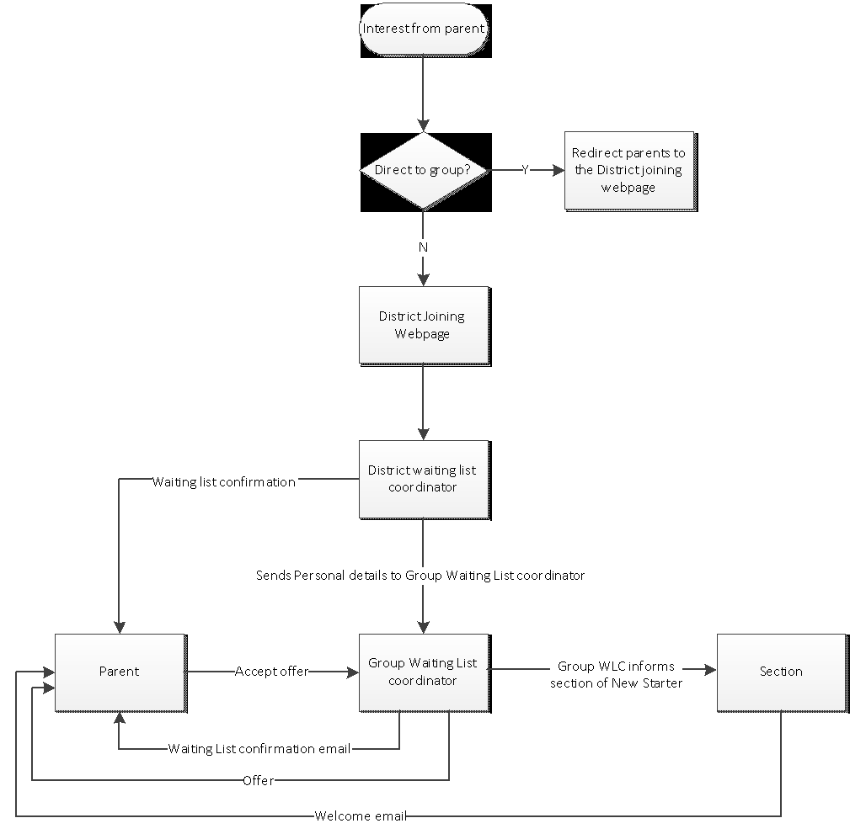

Appendix 2 – Group’s catchment area

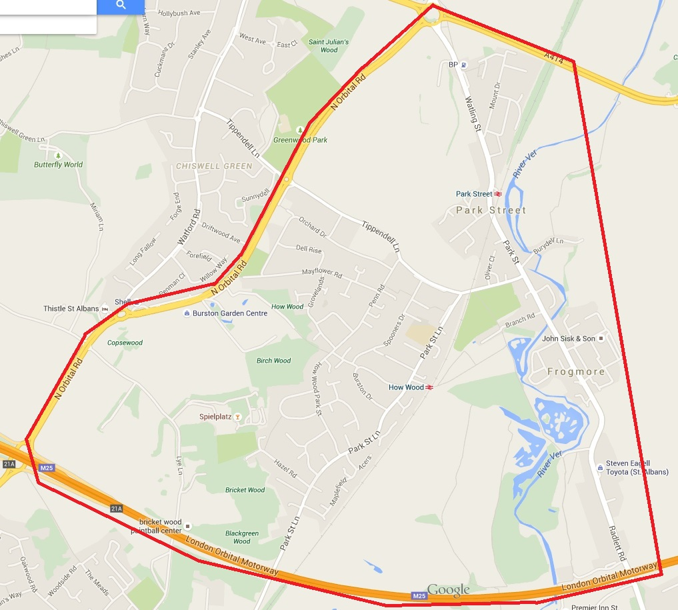

Appendix 3 – Event & Camp Finances

This is an example of a camp budget where the weekend cost was £60 per member

Camp Budget

Expenditure:
Gas 2 x 907’s £27.99e & 2 x CV470’s £7.19e -10% = £70.36
2No. Explorer 175 OS Maps = £11.68
6No. Hultafors Classic 500g Hand Axe - £45.82 each = £274.92
6No. Bahco Laplander folding saw = £106.50
4No. Log Bomb - £7.38 each = £29.40
2No. Double face Sledge Hammers = £31.98
2No. Bow Saws with hand guard = £30.97
Fire Steels x 30 – 99p each = £28.50
3No. Chafing dishes + 12 fuel + 6No. Spoons = £89.50
3No. 50ltr Plastic boxes = £49.97
1No. 14in Vogue heavy duty steel frying pan = £20.49
4No. 10in Vogue heavy duty steel frying pan = £66.76
1No. Aquapod water rocket launcher = £29.99

Total Equipment Cost = £841.02

Camping fees
£4.10 per person per night (2nights in total)
Cubs Scouts 42 x £8.20 = £344.40
Beaver Scout 1 x £8.20 = £8.20
Leaders / Adult Helpers 10 x £8.20 = £82
Total Camp Fee = £434.60

Cost of food
Following menu estimate = £500

Equipment Transportation Cost
Van rental cost = £50

Activity Costs
Bouldering 2 x £32 (Per 1hr of 20cubs each = £64
Total Activity Cost = £64

Cub Badge
Cost per badge £1 x 54 = £54

Coach Travel
Mullany’s Coaches £225 each way = £450

Total Expenditure = £2461.52

Incoming Money
Cost per Cub £60 x 42 = £2520 + £30 x 2 non refund = £60 + Beaver £15 x 1
= £2595 leaves £133.48

Appendix 4 – Group Directory

Executive Committee Contact emails

Group Scout Leader parkstreetgsl@gmail.com

Group Chairman 1stparkstreetchairman@gmail.com

Group Treasurer parkstreettreasurer@gmail.com

Group Secretary / Waiting List Co-ordinator 1stparkstreetwaitinglist@gmail.com

Group Quarter Master 1stparkstreetquartermaster@gmail.com

Group Training Advisors 1stparkstreettrainingadvisor@gmail.com

Website Coordinator 1stparkstreetwebsite@gmail.com

Group Fundraising / Sponsorship 1stparkstreetfundraising@gmail.com

Leadership Team Contact emails

Thumpers Beaver Colony – 1stparkstreetthumpercolony@gmail.com

Conkers Beaver Colony – 1stparkstreetbeavers@gmail.com

Birchwood Cub Pack - 1stparkstreetcubs@gmail.com

Wolf Cub Pack – 1stparkstreetcubswolfpack@gmail.com

Colne Scout Troop – 1stparkstreetscoutscolne@gmail.com

