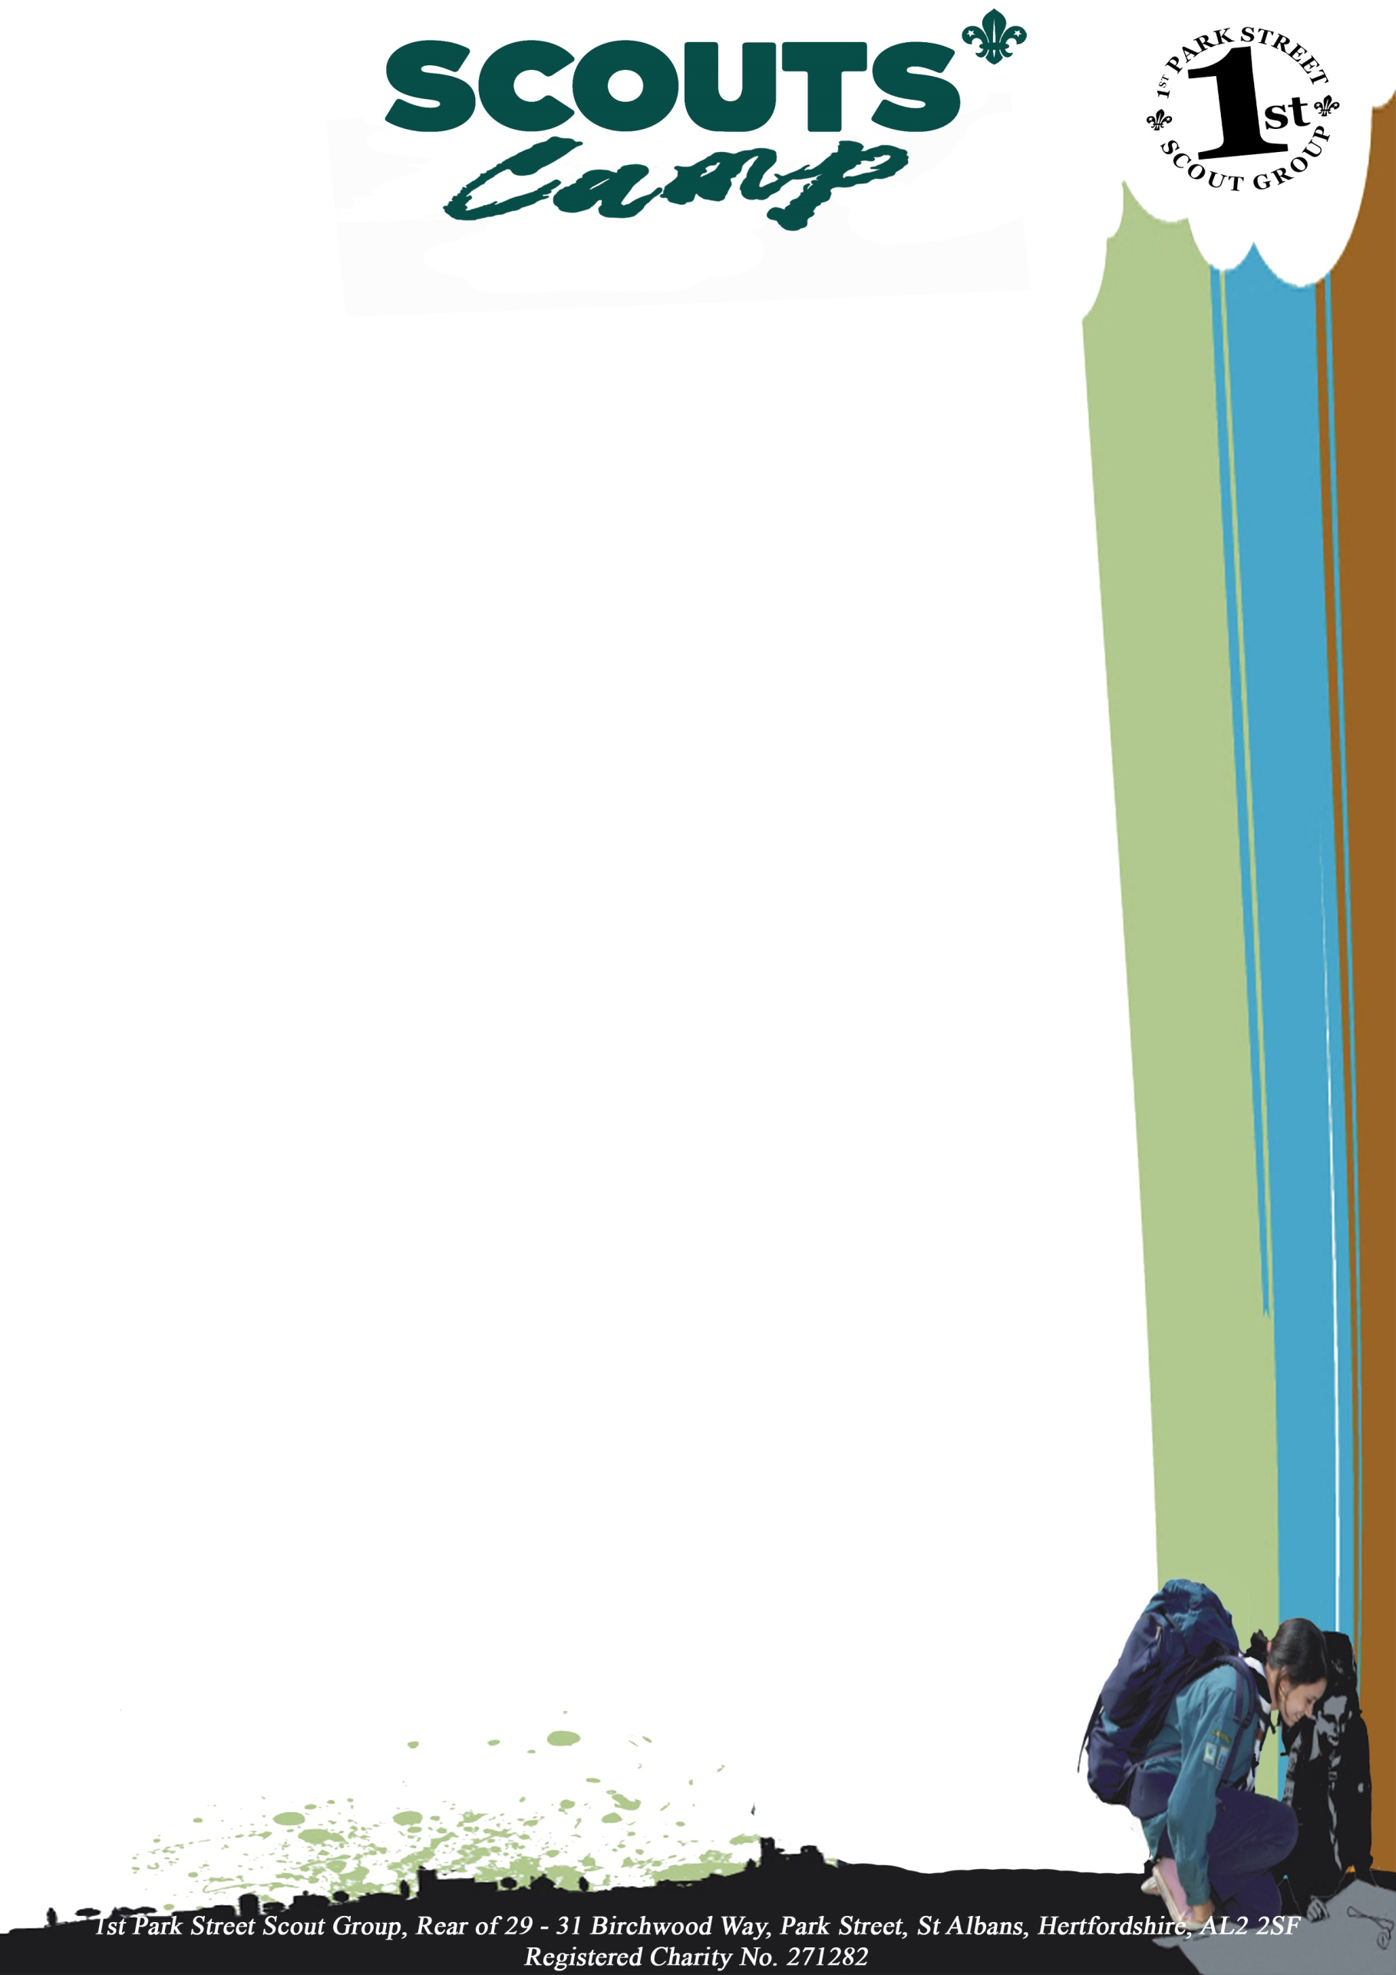

Parents’ Information
Dear parents and carers,
Your leadership team are very excited to be taking your Scout on a weekend camp within tents
to be held at Tolmers Scout Camp.
The information we have provided here should tell you everything you need to know about what
your Scout will be doing and what you need to do to prepare for their experience.
If you have any concerns please let us know and we will endeavour to answer your questions
and put your mind at rest.

The information here includes:
• Transportation arrangements
• Directional map to Tolmers Wood Activity Centre
• Camp site layout plan
• Emergency only contact details during camp
• Sleepover programme of activities
• Camp menu
• Behaviour / Site Rules
• Scout kit list
• Frequently asked questions or F.A.Q.
• Activity Information form – Must be returned by June
• Medicine Administration form – This must be returned before going on camp

Transportation arrangements:

All Scout Scouts shall arrive and leave the camp site in full uniform – Scout jumper, scarf / necker
and woggle.

Drop off at 2pm, Saturday
Please meet us in the car park.
You can say goodbye here and we will take your Scout to the hut.
(This helps to prevent some separation problems).

Pick up at 2pm Sunday

We will be holding a closing ceremony and awarding badges after you arrive.

Camp Site Directions & Site Details:
Tolmers Activity Centre
Tolmers Road
Cuffley
Hertfordshire
EN6 4JS
Tel: +44 (0)1707 872900 e-mail: info@tolmers.org.uk

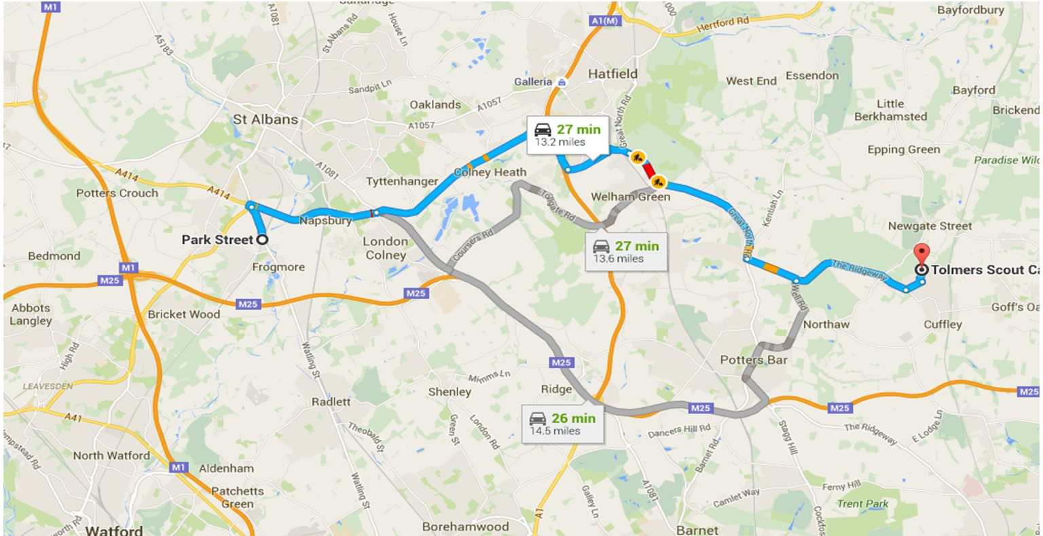

Camp Contact details (Emergency only)
Tolmers Activity Centre Tel: +44 (0)1707 872900
1st Park Street Cubs Camp Leader / Permit Holder
Medical Officer
In Touch Contact
The “In Touch Contact” is only used in the event of serious emergencies and where the leaders on
camp are unable to convey the information directly.
Their role is to have everyone’s emergency contact details and to use them to inform parents and
love ones that there has been an injury.

– Leader 1st Park Street Leader

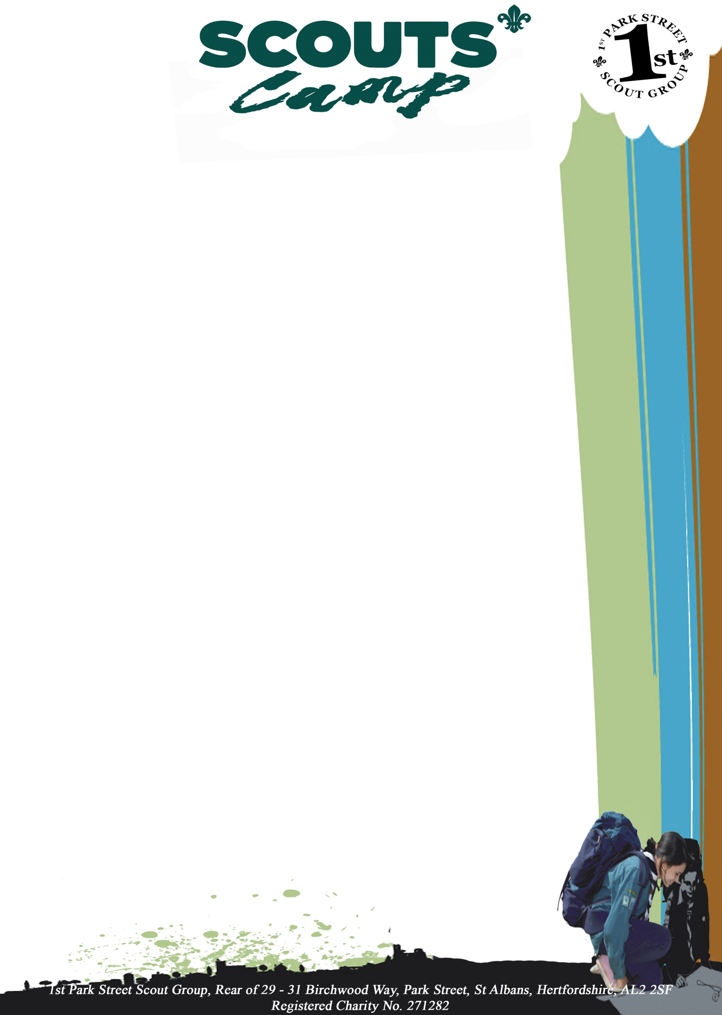

Our Camp Site Pitch: Number(s) –

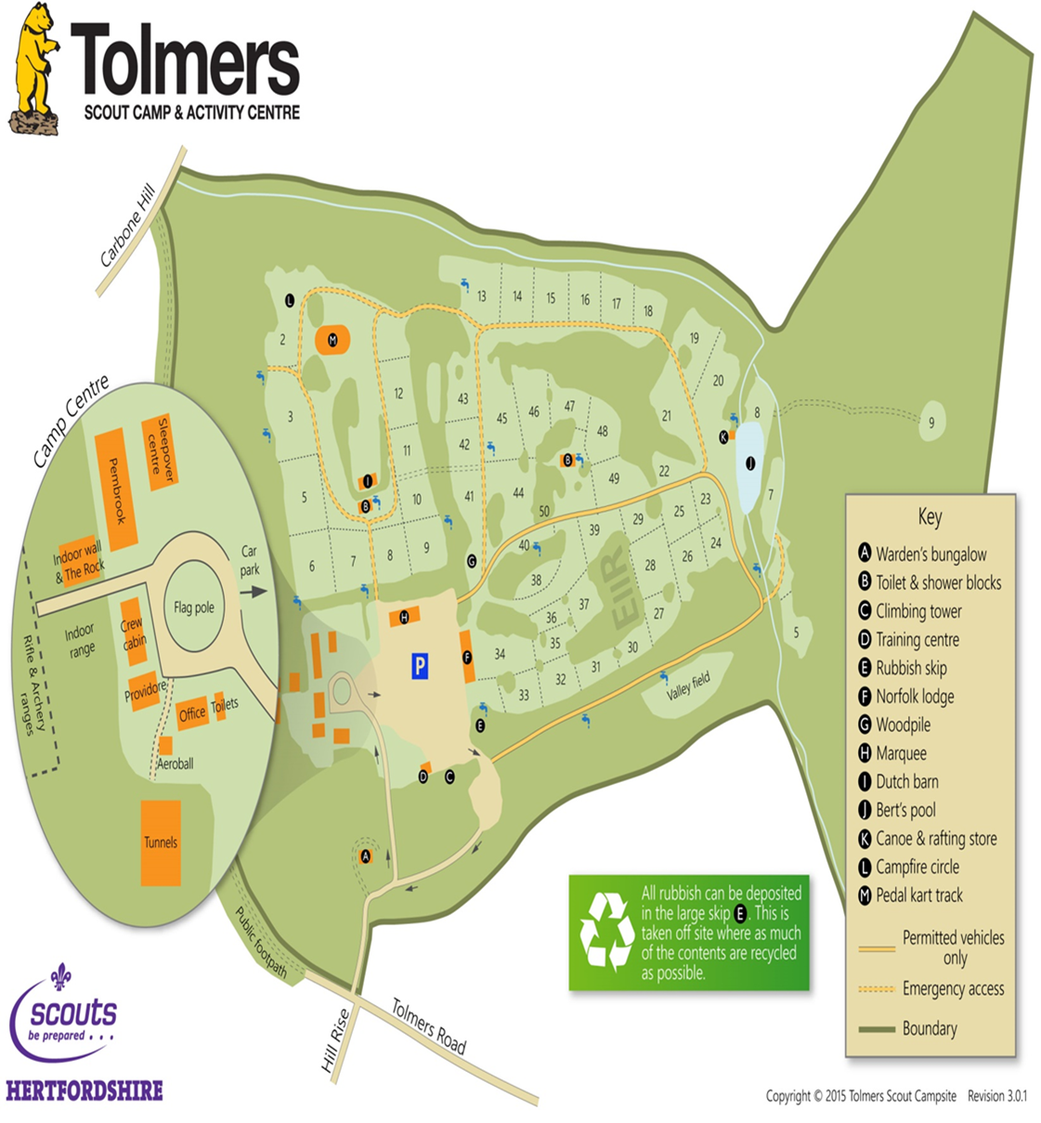

Programme
Friday Evening 27th June

Arrive & settle
Opening Ceremony
Wide Game
Supper

Saturday 28th June

Full English Breakfast

Ariel Trek
Simply, adventure course up in the air. Safely secured with a harness and ropes, they will bravely make their way across bridges, tightropes and balance beams. Have they got the balance to succeed

Crate Stacking
Standing on top of the stack, how high can they build it before it comes crashing down? Requiring balance and confidence, this activity will push their personal limits whilst encouraging team working and communication.

Lunch

Grass Sledging
No need to wait for the snow with these sledges on wheels. Keep arms and legs inside as you zoom down our grass course.

Dinner

Camp fire

Sunday 29th June

Breakfast

Team Building
A number of problem-solving exercises to get the group really working together. The tasks will vary depending on the group but all are designed to be challenging and fun. Each task is reviewed to ensure that the group develop communication and logical thinking skills throughout the activity.

Scout’s own

Lunch

Pack up

Closing Ceremony

Go Home

Sunday

7:30
Breakfast

Wash / Dress / Stow Sleeping Equipment Away

9:00
Cresta run

10:30
Snack

11:00
Orienteering

12:30
Lunch

13:00
Pack up

13:30
Uniforms on

13:45
Scouts own

14:00
Closing ceremony
Parents to Pick up

Menu

Friday Evening
Hot Chocolate / Squash / Water / Biscuits

…………………

Saturday Morning
Cereals (Cheerios & Weetabix) / Cooked Breakfast (Egg, Bacon, Sausage, Beans) / Squash / Water

…………………

Saturday Lunch Time
Hot Dog in a Roll / Fruit / Crisps / Squeeze yogurt / Squash

…………………

Saturday Evening
Spaghetti Bolognese / Bread & Butter / Squeeze yogurt / Squash

…………………

Late Saturday Evening
Hot Chocolate / Squash / Water / Biscuits

…………………

Sunday Morning
Cereals (Cheerios & Weetabix) / Bacon or Sausage Sandwich / Squash / Water

…………………

Sunday Lunch Time
Sandwiches (Tuna / Ham / Soft cheese) / Fruit / Crisps / Squeeze yogurt / Squash

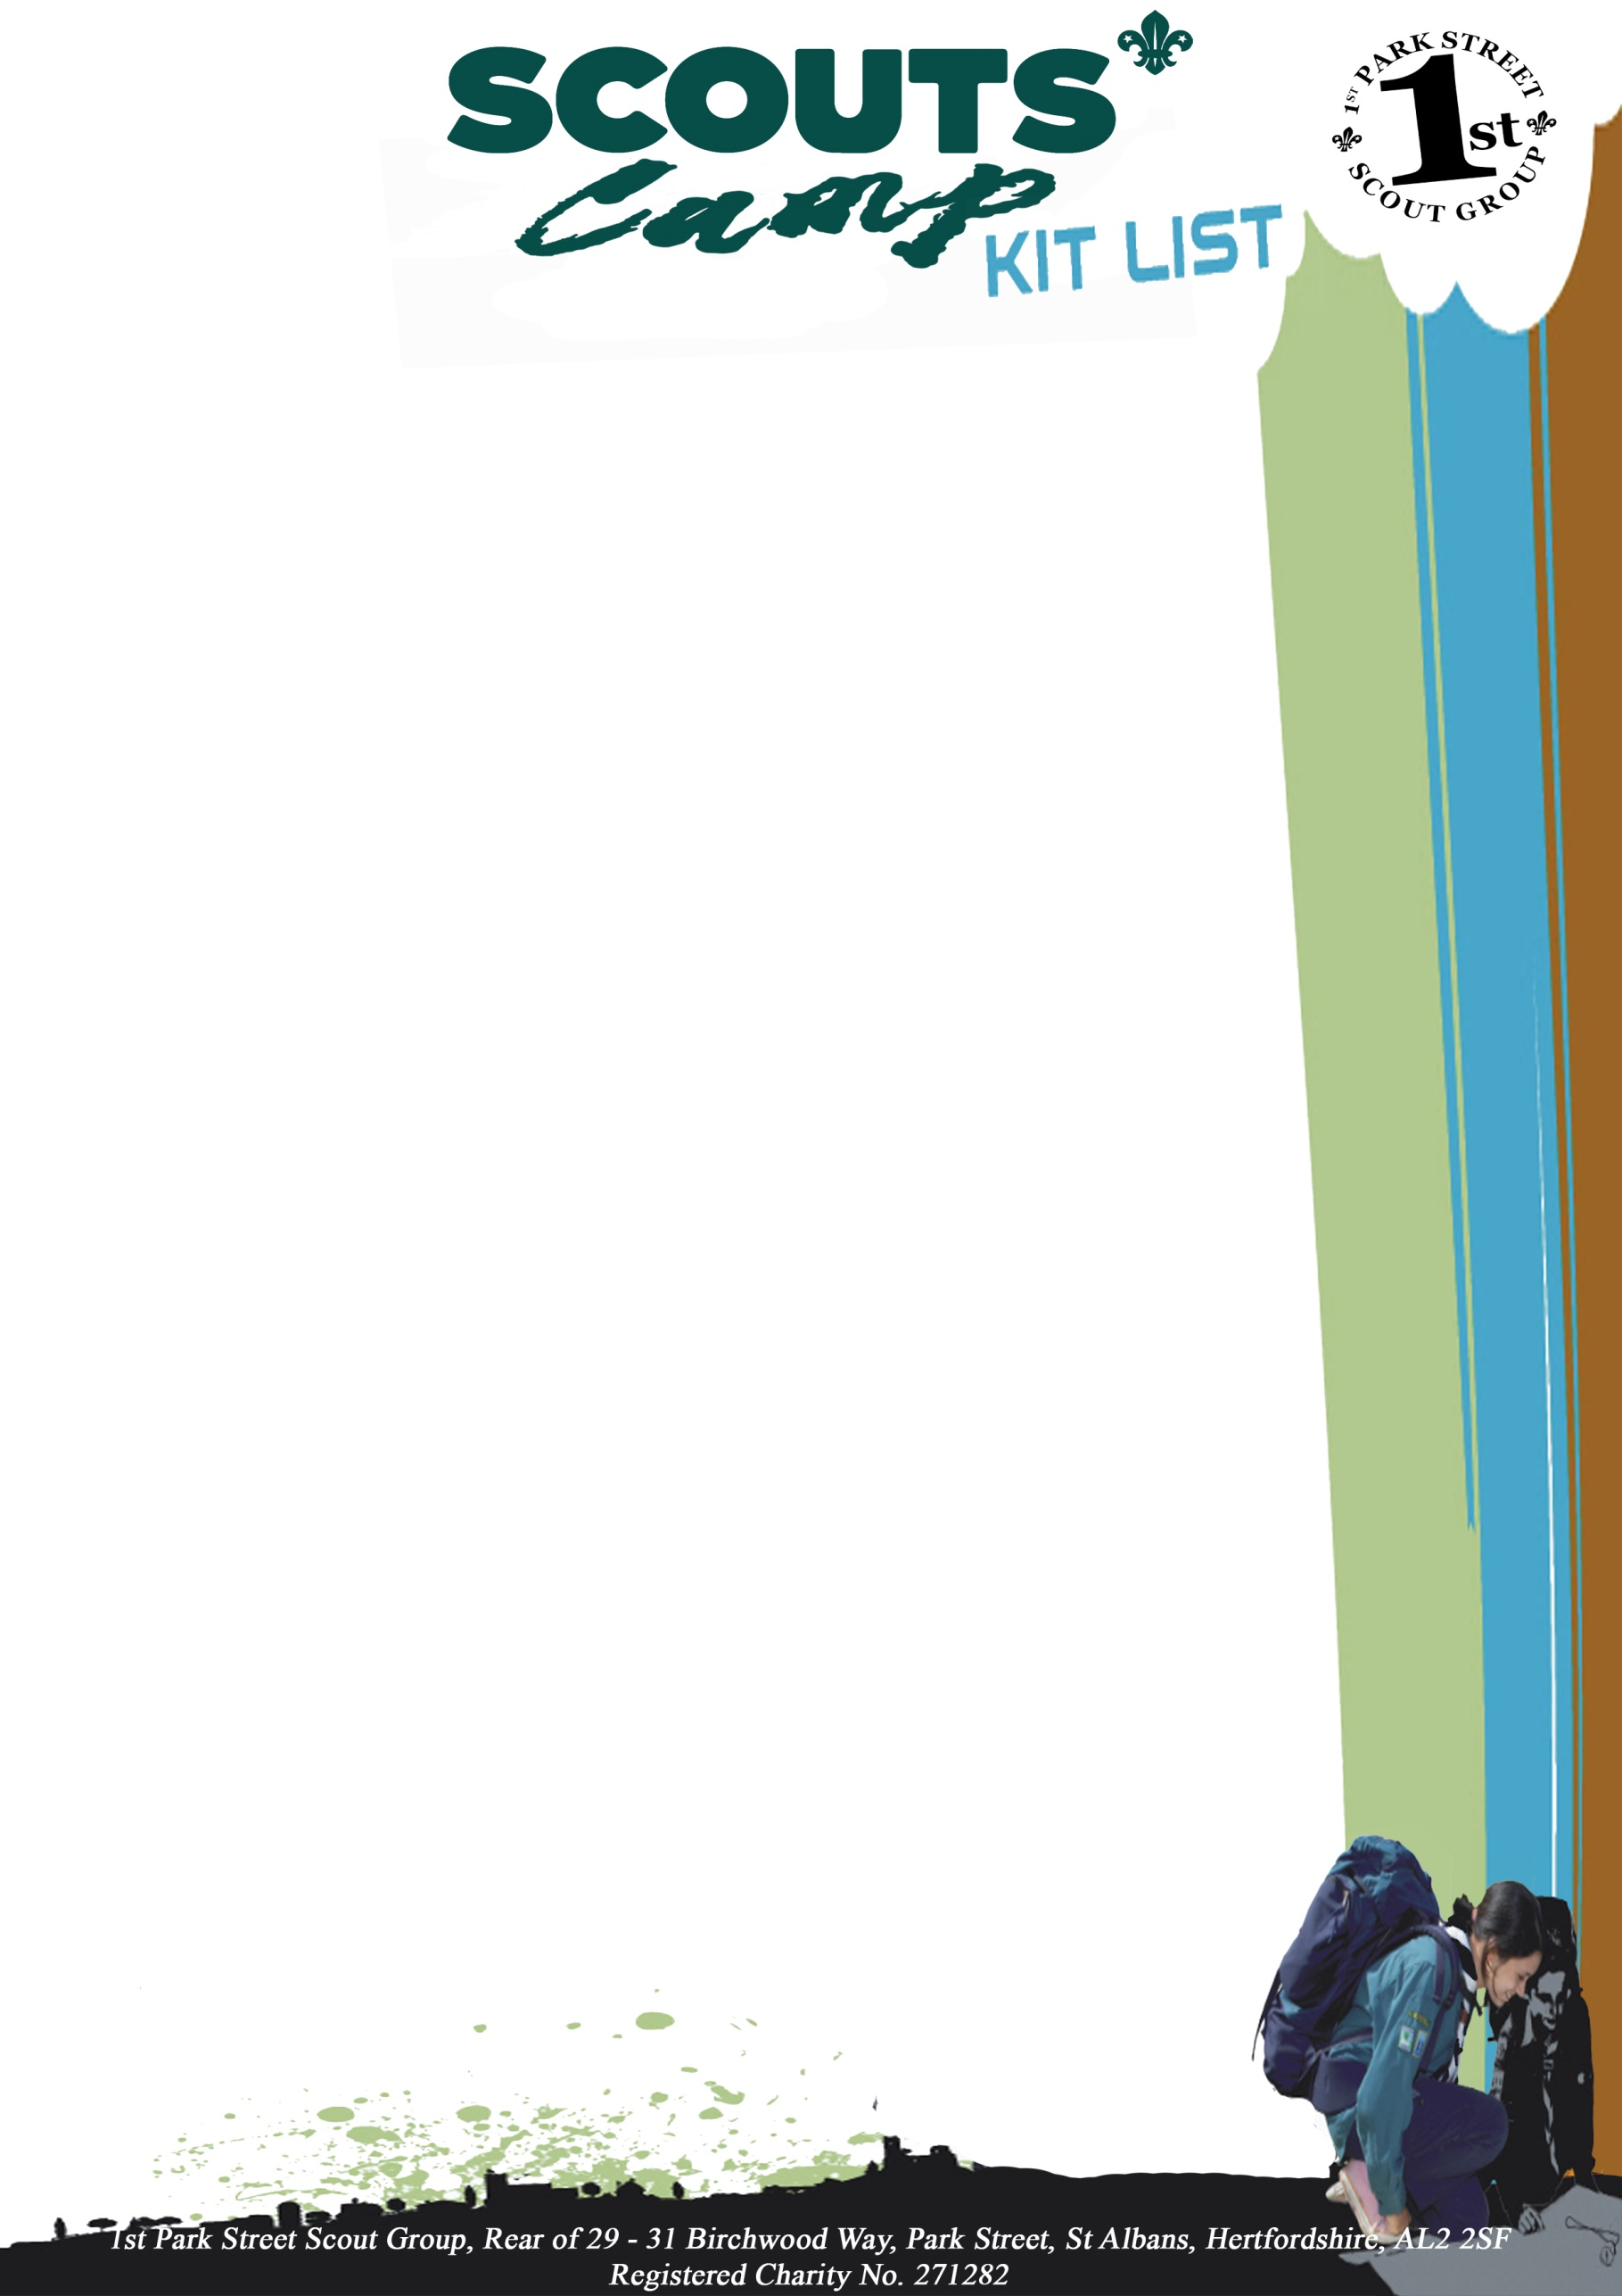

Scout will need to bring their own personal equipment for camps. The following list is a guide to what is generally required although more specific information will usually be supplied at the time by the leader as part of the camp information. We strongly recommend and encourage the parents to allow their Scout scout to pack their own kit within the bag they are using so that they understand what they have, where it is and how to put it back in for returning home.

Packed  - Full Scout Uniform  (Jumper, Scarf/Necker and trousers)  - Coat hanger (for uniform)  - Rucksack / Sports Bag / Holdall  - Plastic bags or sacks for dirty washing/boots  - Waterproof coat (warm coat or cagoule)  - Warm Hat and gloves  - Warm jumpers or fleeces  - Shirts / tee-shirts  - Trousers  - Shorts  - Underwear and socks  - Hiking boots or strong shoes  (wellie boots if neither available)  - Thick socks for walking boots  - Trainers  - Nightwear (Pyjamas or tracksuit)  - Waterproof trousers | Packed  - Sleeping bag  - Pillow  - Indoor shoes / slippers  - Named refillable drinks bottle  - Tea Towel(s)  - Wash bag / kit  (flannel, soap, toothbrush,  toothpaste, brush / comb)  - Towel(s)  - Hankies/tissues  - Torch and spare batteries  (Not high powered)  - Sun cream (if required)  - Teddy

The Scout Group cannot accept responsibility for loss or damage to any personal effects and the
Scout Association does not provide automatic insurance for such items.

All equipment and clothing must be clearly marked with the owner’s name; engraving or
Permanent ink are far better than nail varnish or stuck on labels.

A certain amount of pocket money is recommended. Money may be handed to camp-leader for safety
and will be given out as required. The Scout Group is otherwise not responsible for losses.

Please do not include any electronic games, phones, radios or mp3 players.

Earrings, nose rings, and other decorative jewellery are not recommended on camps and
activities.

Behaviour / Site Rules
The Groups standard behaviour rules and process will be used over the camp are outlined below.
For the groups full and comprehensive behaviour policy please view the group’s website (parents area)

STANDARD OF BEHAVIOUR:
Scout should act with manners and pay respect to other Scout, leaders and adult helpers.
At times behaviour is unacceptable and methods have been employed by following the 4 staged approach below.
Some examples of unwanted / unacceptable behaviour:
- Bullying including physical violence / Verbal abuse of any kind
- Disrespect, Answering back to leaders or adult helpers
- Inability to follow instructions given by an Instructor, Leader, Adult helper
- Talking whilst another person is talking
- Disregarding instructions which could result in personal harm to themselves or others
- Deliberately damage property belonging to the Group or another person
- etc.

1. INFORMAL STAGE:
Young person is informed their behaviour, attitude or response to others is unacceptable.
This can be done by a leader or adult helper.
Young person is given an opportunity to improve unwanted behaviour.

2. YELLOW CARD PROCEDURE:
Yellow Card issued = 1st warning
3. RED CARD PROCEDURE:
Red Card issued = 2nd warning
Some behaviour will warrant a straight Red card which physical violence is one
4. DISMISSAL:
It may become necessary to dismiss the young person if despite above procedure and help and support from the leadership team fails to reach an acceptable level of behaviour.
The Scout leader will inform the parent to come and collect the child.

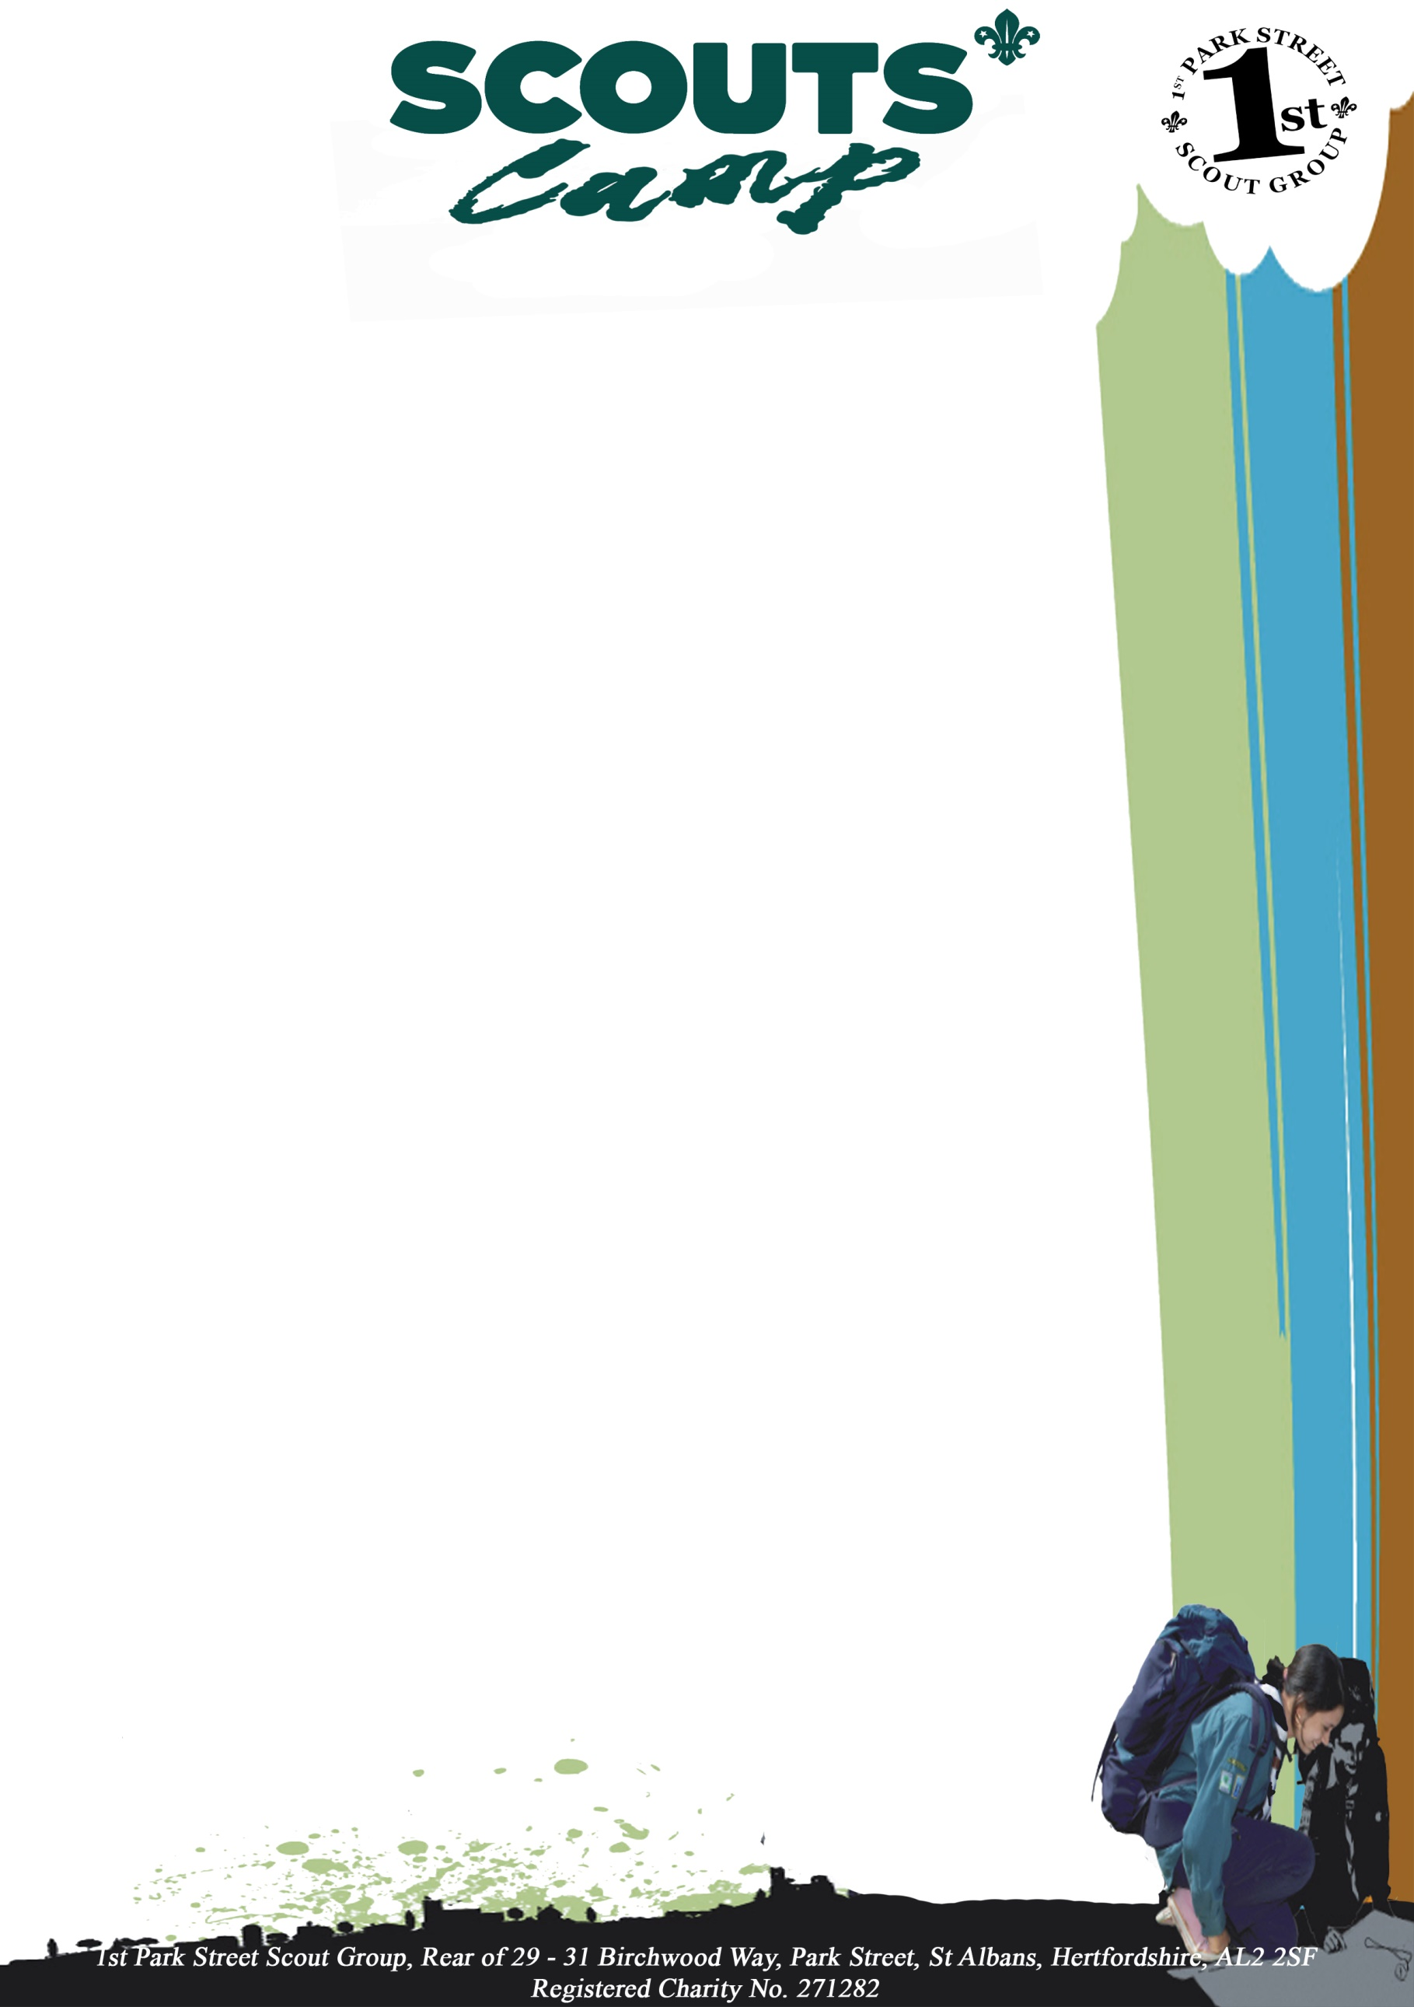

Your Questions Answered

Do boys and girls sleep separately?
Yes, there will be separate rooms for boys and girls

Do adults sleep with the Scout?
No. Adults sleep in separate rooms, close by.

Do all the adults have DBS checks?
Yes, all leaders or adult helpers staying overnight have to have current Scouting DBS checks

Will a Scout be left to cry him / herself to sleep?
No. We hope to have the Scout exhausted enough that getting to sleep isn’t a problem. Most will
just get ready for bed and go to sleep because that’s what everyone else is doing. If a Scout is a
little wobbly two adults might sit with them. If a Scout is very distressed and shows no signs of
calming then we will contact you.

Can my Scout bring a phone so they can call me to say goodnight?
No, we find that talking to parents in the evening can have a negative effect at a time when the
children don’t need it. Scout are asked not to bring phones or any electronic toys or devices.
If you can’t get to sleep and are worried about our child then we are happy for you to call us for
reassurance.

What if the Scout need to go to the loo in the night?
The Scout will be encouraged to go to the toilet right before bed, but if they do need to get up in the
night they will be told to take another child with them to the toilet. Our camp is close to and in clear
view of the lit toilet block. The leaders’ rooms will be close by the Scout, so if they need anything
we are available to help.
Leaders will be doing regular room checks before turning in themselves to make sure all the Scout
are OK.

My child sometimes wets the bed.
Letting us know helps it means we can make sure they go to the loo late on and we can keep our eyes
open to help if this happens. We will have spare sleeping bags for these events. If your child wears
pads at night they will be able to put these on and take them off in privacy.

My child sometimes forgets that they need to go to the toilet.
If this is a particular problem let us know and we’ll try to remind them and make more opportunities
available.

What if my Scout doesn’t like the food?
There is some element of choice in the meal if we are told before going on camp. If you see something
on the menu which is within this pack that you think your child won’t or can’t eat, please tell us
straight away and we’ll try to arrange an alternative. We won’t leave a Scout hungry however due to
budget we are unable to cater to whims

.

Will my Scout be forced to do anything challenging?
No. Although activities may involve heights, the dark etc. we won’ force a child to do something
they are not comfortable with. Have a look at the programme to see what we have planned.
We encourage the Scout
to take part in new activities but respect their decision and would expect other Scout to respect
that too.

What about medication?
All required medication will be labelled with the child’s name along with a signed medical form
(found within this pack). These will be handed to the camps medical officer who will supervise
The Scout taking the medication.

Should I give my Scout any money?
There is a small tuck shop on site where they do sell sweets and other bits which the Scout will
be given the opportunity to go. We would state the maximum that should be given is £3 and this
money must be handed to the camp treasurer before camp in a named envelope or purse/wallet.
They will hold this for the Scout and will hand out the amount to Scout as required.

It’s hard to fit all the kit in one bag
Use a big bag rather than try to ram everything into a smaller rucksack. Your Scout won’t
have to carry it far. Lots of loose stuff or a bag rammed tight means that the Scout simply can’t
find the things they need.

Does everything need labelling?
Yes please. It helps. Even things like sleeping bag covers and straps. It also helps if you get your
Scout to help pack, so they know what they’ve got and where it is.

Do Scouts get a badge?
This will be dependent upon each Scout previous scouting experience.
Each night away from Scout onwards accumulates for the Nights Away Stage badges which starts
at 1 for their first night away and then goes up in increments of fives.

The activities that the Scout will be doing while on camp may also qualify for parts of badges such
as their Challenge badges.

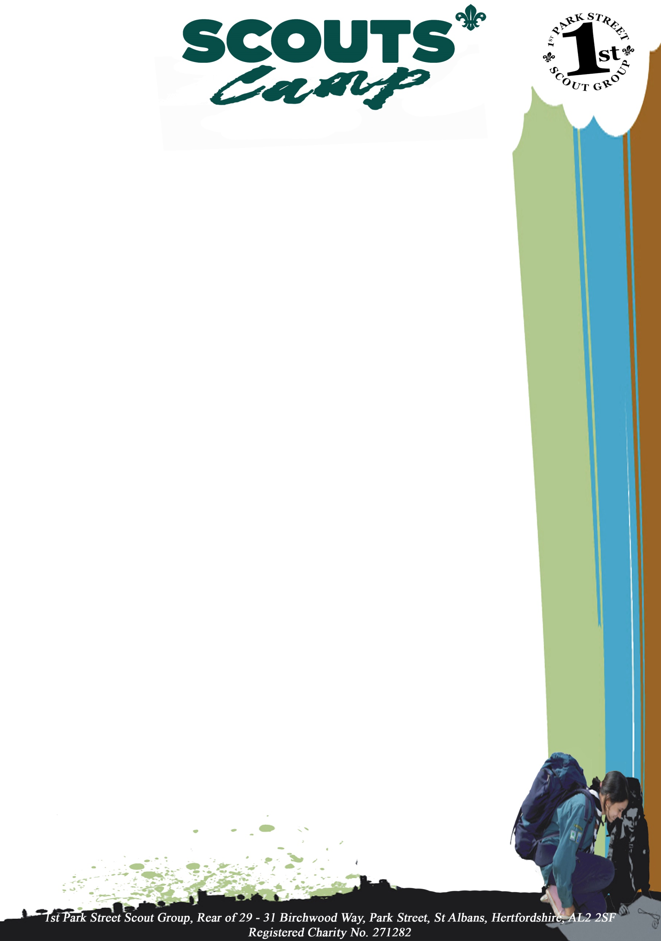

Activity Information Form
Event: |  | Date:
Camp Site Location: | Tolmers Wood Scout Camp, Rucklers Lane, Kings Langley, Hertfordshire WD4 9NA
Drop off place and time: | Tolmers Wood Scout Camp Site Car Park – 2pm –
Pick-up place and time: | Tolmers Wood Scout Camp Site Car Park – 2pm –
Full Cost / Deposit Cost | Full Cost £ – Non-refundable Deposit £xx by xxx
Transport details: | Parents to Drop off and Pick up at Meeting and Collection point
Wear / Bring: | Full Uniform plus Suitable clothing depending on weather conditions
Further details: | All details are to be found with the parents camp information pack
Organiser and contact details:
Contact details during the event: | As Above or as others stated within the parents camp information pack
Please keep this section for your own information, and detach and return the section below.
Note: All activities will be run in accordance with The Scout Association’s safety Rules. No responsibility for the personal equipment/clothing and effects can be accepted by the organisers and The Scout Association does not provide automatic insurance cover in respect to such items.

Please complete and return this section to any member of your Leadership Team by
Name of young person: |  |  | D.o.B:
Event: | Scout Camp - Tolmers Wood Scout Camp, Rucklers Lane, Kings Langley, Hertfordshire WD4 9NA
I have noted the arrangements above and agree to the named young person taking part.

Emergency contact: |  |  | Phone:
Doctor’s name and contact details: |  | Details of any medications currently being taken:
Details of any disabilities, conditions, allergies, special needs or cultural needs that might affect this activity: |  | Details of any infectious diseases he/she has been in contact with in the last three weeks:
If it becomes necessary for the above named young person to receive medical treatment and I cannot be contacted to authorise this, I hereby give my general consent to any necessary medical treatment and authorise the Leader in charge to sign any document required by the hospital authorities.
Signed: |  | Date:
Relationship to young person:

Note: The medical profession takes the view that the parent’s/ carers consent to medical treatment cannot be delegated. This view is explicit in The Children’s Act 1989. Thus, medical consent forms have no legal status and a doctor or nurse insisting on the consent of a parent carer to a particular treatment has the right to do so.For this reason we do not recommend that Leaders insist on parents/carers signing the statement above. However, it can be a comfort to medical staff to have general consent in advance from parents/ carer's or to have a Leader on hand able to sign forms required by medical authorities

Medicine Administration Form
Leader’s Details
Section: | X Scout Troop
Name: | SL First Aider | Telephone:
Address: | N/A
E-Mail Address: |  | Mobile:

Name of Young Person:
Date of Birth:
In consideration of the Designated Nights Away First Aider / First Aiders being them the Section Leader or Assistant Section Leader of Birchwood / Wolf Cub Pack of the 1st Park Street Scout Group, agreeing to administer medicine to the above-named child on my behalf during section meeting times or camp, in accordance with the official instructions supplied therewith, I hereby undertake to bring the necessary medicine to the section meetings or camp and to hold harmless and indemnify the said Section Leader or Assistant and the 1st Park Street Scout Group against any claim of any nature whatsoever arising from the administration of the medication to my child.
I hereby give my permission to administer to my child | CalPol “Six Plus”  As per instructions upon the box | Yes / No | Piriteze “Allergy Syrup”  As per instructions upon the box |  |  | Yes / No
Parent or Guardian’s Signature
Date:
Parent or Guardian’s Name: |  |  |  | Mobile:

